z

iStockphoto.com/Ivar Teunissen



**Introduction to sport psychology**

**What is sport psychology?**

sport psychologists What are the skills?

**Sport psychology techniques** goal-setting and motivation mindset—thinking for excellence

**Arousal, stress and relaxation**

the inverted u curve relaxation strategies

**Mental strategies for peak performance**

routine

mental rehearsal

improve focus and minimise distractions Flow for the ultimate performance

# **What is sport psychology?**

Sport psychology is the scientific study of the mental and emotional factors related to performance in sports. Although there has been interest and study in the area of psychology and sports for over 100 years, the field of sport psychology emerged in the late 1960s. Research in the area has become extensive and the practice of using psychology to facilitate excellent sporting performances has seen a steady growth in popularity. Champion athletes and professional sporting teams have sport psychologists as part of their coaching and support crew to assist them to perform at their best. Today, skills in sport psychology are commonly accepted as valuable tools that sportspeople of any age or skill level can benefit from. They are relevant for anyone who wants to improve their performance in a sporting pursuit, whether it is for fun and fitness, elite competition or anything in between.

The pie chart shows the elements that are required for excellent sports performances. To be able to perform at one’s best in

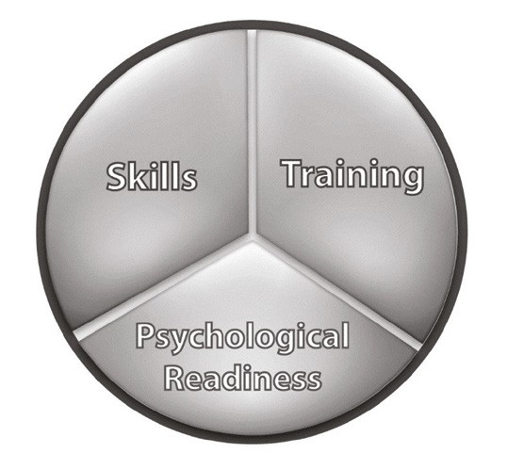

*Performance elements*

a sport, a person requires skills such as physical strength, endurance, speed and knowledge of the sport. Training is essential to continue to develop and improve skills. Psychological readiness (the right mindset) is also an essential part of performance. Sport psychology helps us understand how our thinking relates to our emotions and actions. We can learn to use mental skills to deliver our best possible sports performances.

## **Sport psychologists**

Sport psychologists are psychologists who specialise in the area of sports performances. They work with individuals and teams to help them perform at their best. A sport psychologist may be involved with research, provide education or help with specific skill development. They may be employed by clubs, institutions, individuals or work in private practice.

## **What are the skills?**

Important concepts taught in sport psychology include goal-setting, positive thinking and self-talk, confidence, arousal, stress management, relaxation, routine, mental rehearsal, focus, flow and overcoming challenges.

These skills have been shown to be very effective in assisting sportspeople to excel. They can also be applied to many other areas of life and coaching in order to enhance performances, for example, business, musical or dramatic performances, academic pursuits, or public speaking.

#### *The psychological side of sports*

1 As a class, brainstorm the concepts taught in sport psychology and create some basic definitions or explanations for these terms. Why might these skills be essential for peak performances? Write in the spaces provided.

Goals

Motivation

Positive mindset

Confidence

Self-talk

Arousal

Stress

Relaxation and recreation

Routine

Mental rehearsal

Teamwork

Focus

Overcoming setbacks and injuries

1. List three settings in which a sport psychologist could be employed.
2. List some of the mental or psychological qualities displayed by successful sportspeople.
3. Describe an example of an action or behaviour that reflects one or more of these qualities. You may write about a situation using a famous sportsperson or someone that you know or have watched.

###### Dream large

1. If you could achieve anything, what would it be? Imagine there are no obstacles. Your dream may be a sports dream or it may be something else. You may have more than one dream. Record your response in the space provided.

# **Sport psychology techniques**

## **Goal-setting and motivation**

### Set a direction and achieve more!

iStockphoto.com/Rakoskerti

For a moment, consider your ambitions or your heart’s desire. If a person has a goal that they really want to achieve, the first step is to make a commitment. They are making a mental promise to work hard, meet challenges and keep persisting so they can achieve their dream.

Goal-setting is a powerful tool to help turn this dream into a reality. Goal-setting is a technique that is used by top-level sportspeople (as well as business people and other very successful people) to build confidence, increase focus and provide motivation. It is a concrete map for their path to success. Setting goals allows you

to think about the steps required to achieve your dream, organise priorities, manage time and make a written commitment. It helps people to recognise and minimise distractions that will impact upon achieving their goals.

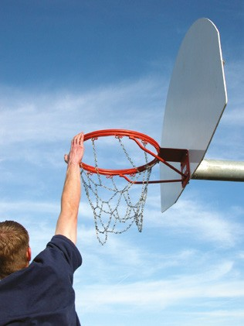A well-defined and specific goal plan will act as a MAP to:

iStockphoto.com/terminator1

* increase **motivation, M**
* set down your **action** plan, and **A**
* track your **progress. P**

### Types of goals

##### *Short-term goals*

These are usually smaller goals that you can aim for and achieve in a relatively short time frame (say, less than one year). Short-term goals are often set with a bigger or long-term goal in mind that you are working towards. For example, if your ultimate goal is to break an Olympic record in long jump, some examples of short-term goals might be to achieve a personal best (PB), to train five times a week or to break the athletics club record.

##### *Long-term goals*

Long-term goals are usually bigger goals that will take a sustained effort and focus to achieve. They may take a long time. These are most often achieved with the individual working through a succession of short-term goals that will lead to the long-term goal. The long-term goal provides an ultimate vision and motivation for working through the short-term goals.

#### *Applying knowledge*

1. Can you think of an example of a long-term goal that a sportsperson might have?
2. Develop a long-term goal that relates to your performance in the sport you are currently studying in practical lessons.
3. List three short-term goals that will help you work towards achieving your long-term goal.

##### *Process goals*

iStockphoto.com/mirefa

Process goals commonly involve skills or activities and often relate to training or practice. They are within your control and you can measure them. For example, if the team hopes to increase fitness so that players are quicker and less fatigued on the football field, this is an objective over which the individuals and team

has a lot of control. They can commit to regular training schedules and they can measure fitness levels at regular intervals.

##### *Performance goals*

Performance goals are goals that relate to your actual performance relative to your own standard (for example, personal best or consistent performance level). For example, the goal may be to achieve a personal best in pole vault this season with a 3 cm increase in jump height.

##### *Outcome goals*

Outcome goals relate to the outcome, for example, winning the game, being selected to go on the sports tour or running the fastest time in the competition. The difficulty with setting an outcome goal is that the individual does not control all the variables—the outcome often is related to the performance of the opposition. You may swim your best time ever, but someone else swims faster.

#### *Considering different goals*

* 1. In the table provided, write the main differences between the various goals.

|  |  |  |  |
| --- | --- | --- | --- |
|  | **Process** | **Performance** | **Outcome** |
| **Short-term** |  |  |  |
| **Long-term** |  |  |  |

* 1. Consider your long- and short-term goals. Identify whether your goals can be identified as process, performance or outcome.

### Setting goals

If you are setting a goal, it is important to identify exactly what it is that you really want to achieve. Consider what kind of goal you are setting (short-term, long-term, process, performance or outcome). A realistic and achievable goal will be one that is challenging, but not too difficult to accomplish.

##### *SMART goals*

An acronym that is commonly used to describe and remember the elements of goal-setting is ‘SMART’.

**S**pecific (What actions will you do?)

**M**easurable (How and when will you measure activity or progress?) **A**chievable (Is the goal challenging, but not impossible to achieve?) **R**ealistic (Is your plan and time frame realistic—can you stick to it?)

**T**ime frame (Set days and times for your activities and a date for completion and/or review.)

For example, if Tom wishes to improve his ability to shoot goals in basketball, which approach do you think will be most effective in making this goal a reality?

iStockphoto.com/Photawa

**A**: ‘I hope to improve my goal shooting.’

**B**: ‘I will practise shooting goals three times a week for six weeks. I will do this for 45 minutes on a Monday, Wednesday and Thursday straight after school.’

Tom is more likely to follow through with ‘B’ because he has thought about how he will achieve his goal of improvement in making a time for practice. He has set a short-term process goal.

Tom could also have chosen a performance goal. At the moment he can score a goal in four out of ten attempts. His goal might be to increase this scoring rate to seven out of ten. He might decide that a reasonable time frame is six weeks based on his knowledge and experience. Tom can write down his goal and monitor his progress. He may find that he achieves his target in three weeks. If this happens he might review his goal and try to shoot from the three point line or introduce

a distraction. If after six weeks Tom has not achieved his goal, he may find that he needs to review the time frame or the amount of practice he is doing. Even if he does not quite achieve his aim, Tom may still be pleased with his progress and will know how far he has come.

You can make your goals even SMART–**ER** by adding **E**valuation and **R**ewards.

**E**valuation It is very important to keep your goals in mind and review them regularly. Was your time frame realistic?

Was your goal achievable? Are you on track?

**R**ewards Keep yourself motivated by having a list of ‘rewards’—things you can do or enjoy to give yourself a pat on the back for your small successes. For example if I stick to my rehearsal schedule every week, I will...

* treat myself to a sports magazine
* rent a DVD to relax
* take a day off training
* go out with friends.

It is very important to acknowledge and celebrate your progress!

##### *Sample of Tom’s SMARTER goal plan*

Goal: To increase goal shooting success rate from 4/10 to 7/10.

|  |  |
| --- | --- |
| **S** | I will shoot goals three times a week for six weeks. |
| **M** | I will test myself once a week and record the result. |
| **A** | I know that previously when I practised each day I improved within 2 weeks—this is a challenging but achievable goal. |
| **R** | If I train straight after school I will be able to stick with it as I am usually free at this time. |
| **T** | I will do this for 45 minutes on a Monday, Wednesday and Thursday straight after school for five weeks beginning April 6. |
| **E** | I will review this plan after six weeks. |
| **R** | Each week that I achieve my training target, I will reward myself by going out with friends on Friday after school. |

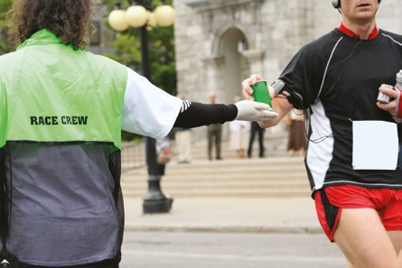

***Sample of Tom’s record sheet***

|  |  |  |  |  |  |  |
| --- | --- | --- | --- | --- | --- | --- |
|  | **Week 1** | **Week 2** | **Week 3** | **Week 4** | **Week 5** | **Week 6** |
| **Date:** | **April 6** |  |  |  |  |  |
| **Practice X /** ✓ **: Monday**  **Wednesday Thursday** | ✓  ✓  ✓ |  |  |  |  |  |
| **Progress** | Score  /10 | Score  /10 | Score  /10 | Score  /10 | Score  /10 | Score  /10 |
| **Reward?** | Go out Friday  ✓ |  |  |  |  |  |
| **Review Date:**  **Comments** |  |  |  |  |  |  |

#### *Rewards*

1 List some ‘rewards’ you can use to motivate yourself to stick with your goal plan. They do not need to be expensive or large.

#### *Make your own goal plan*

1. Consider the type of goal you wish to set (a short-term process or performance goal is recommended). You can choose a sports goal or any goal that is important to you (such as music, leadership or academic).
2. Use the goal plan template to write up a SMARTER goal plan—ensure your goal is specific, measureable, achievable and realistic. Set time frames for your actions, evaluate how you are progressing and include rewards for your success!

###### Tips:

* + Place your goal plan where you can look at it regularly.
  + Share your goals with someone who will support you.
  + Work with a partner who also has goals so you can motivate each other.
  + Research shows that the biggest challenges to following through with a goal plan include: time pressure, academic commitments, social relationships, stress and fatigue.

##### *Goal plan*

Goal:

|  |  |
| --- | --- |
| **S** |  |
| **M** |  |
| **A** |  |
| **R** |  |
| **T** |  |
| **E** |  |
| **R** |  |

1. In the box, design your own record sheet using the sample provided.

#### *Managing goals*

1. Why is it important to set goals?
2. List two or more strategies a person might use to help them stay motivated to achieve their dreams.
3. Why is it helpful to write down and display goals?
4. What are three challenges that people might face when following through with their goal plan?
5. Develop one or more strategies that a person could include in their goal plan to help them overcome these challenges and stay on track.

## **Mindset—thinking for excellence**

Skill development, training and good physical health are essential to improve and be competitive in sports. Another crucial element that can make or break a performance is a person’s mindset. Mindset is really about thinking. It may include

a person’s view of themselves and their abilities (confidence, self-belief), the way they interpret or explain situations to themselves and the way they motivate, encourage or criticise themselves (their self-talk).

Many skilled and talented sports professionals have had times when they have not performed to the best of their ability due to mental obstacles. A term often used to describe this in sports is ‘choking’. Examples of such psychological obstacles include:

* + lack of self-belief or confidence (‘I can’t beat her, she’s too strong’)
  + fear (of losing, of taking a risk)
  + stress/pressure (‘If I don’t win this, I am a total failure’/‘Bob will be disappointed/angry if I don’t win.’)
  + worry (‘What if I don’t swim well today?’)
  + distractions/lack of focus (this could be due to some disruption like someone in the crowd yelling out or due to thinking or worrying about other things unrelated to the sport)
  + self-blame (‘It’s all my fault we lost’)
  + negative thinking (‘I won’t … I can’t … I’m not good enough’)
  + believing negative things said to you or about you.

The ‘right mindset’ means to think in a way that will help you, that will propel you to success. For example, in order to be confident a person needs to have an unwavering self-belief that they can achieve—no matter what happens or what anyone says.

To learn to do this, a person must first listen to their self-talk (the thoughts that they have) and understand how thinking directly affects emotions and actions. Many people believe that feelings are a result of situations or events—the things that happen. This is not true. Feelings arise from *our interpretation* of events—our thinking, perceptions and judgements about the event. Psychologist Albert Ellis uses a model to explain this:

###### Event (A) → Thought or ‘self-talk’ (B) → Feelings (C)

Example:

**Mary, Hawthorn supporter**

|  |  |  |
| --- | --- | --- |
| **Event (A)** | **Self-talk (B)** | **Feelings (C)** |
| Hawthorn loses the Grand Final | It is not fair, we worked so hard. We deserved to win. | Disappointment, maybe even very upset or angry. |

**John, not interested in football**

|  |  |  |
| --- | --- | --- |
| **Event (A)** | **Self-talk (B)** | **Feelings (C)** |
| Hawthorn loses the Grand Final | Oh, did they? | OK |

**Brendan, Hawthorn supporter**

|  |  |  |
| --- | --- | --- |
| **Event (A)** | **Self-talk (B)** | **Feelings (C)** |
| Hawthorn loses the Grand Final | We were so close! What a fantastic game—we played really well. It is too bad we lost, but it is only a game. | OK—maybe a bit disappointed. |

**Jack, Collingwood supporter**

|  |  |  |
| --- | --- | --- |
| **Event (A)** | **Self-talk (B)** | **Feelings (C)** |
| Hawthorn loses the Grand Final | Yes! We beat them! We won the premiership! | Very happy, elated. |

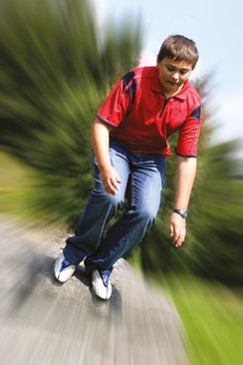As you can see from this very simple example, the situation is the same for all four people, yet they view it differently and they feel very differently. Both Mary and Brendan are Hawthorn supporters but they view the loss differently and, as a result, Brendan does not feel as badly as Mary does.

iStockphoto.com/duncan1890

###### This is the key to a positive mindset!

We can listen to our thoughts and choose to think things that will allow us to feel confident and good about ourselves. It is very important that the thinking we choose is positive and realistic. This allows us to have real hope and confidence, and to look ahead. An example

of a positive (but unrealistic) thought is Kate believing that she will win the gold medal at the club gymnastic competition when she has only just started and many other competitors have been training for years.

#### *Thinking about it*

1. Comment on how an understanding of the link between thoughts and feelings can help in sports.

### Five steps to thinking like a winner

* 1. **Identify** self-talk. (Really listen to your thoughts.)
  2. **Evaluate** self-talk. (Are your thoughts true and accurate?)
  3. **Challenge** the self-talk. (Are these thoughts helpful? Are there alternative thinking options?)
  4. **Generate** a positive alternative thought. (Think of self-talk that is positive and helpful.)
  5. **Choose to think in a positive way**. (Continue to reflect on thinking and challenging negative self-talk.)

#### *Creating a new mindset*

1 The following activity provides examples of negative self-talk that a sportsperson may have. First, write in a feeling that could relate to their self-talk Next, write an alternative thought that constitutes positive self-talk. Below that, write the feeling that could relate to the new self-talk.

1. Thought: ‘Every time I compete against this guy, I lose. I may as well not bother to turn up.’ Feeling:

Alternative thought:

Feeling:

1. Thought: ‘I’m sure I’ll do something wrong. If I mess up the coach will be mad with me.’ Feeling:

Alternative thought:

Feeling:

1. Thought: ‘In the last athletics competition I knocked over two hurdles. It will happen again today.’ Feeling:

Alternative thought:

Feeling:

1. Thought: ‘That tough girl on the other netball team is staring me down. She hates me.’ Feeling:

Alternative thought:

Feeling:

1. Thought: ‘If I can’t block this goal we will lose and it will be all my fault.’ Feeling:

Alternative thought:

Feeling:

A lot of research has been done on the power of a positive mindset. People who have an optimistic outlook have been shown to be higher achievers in a whole range of life areas including sports, academic pursuits, business and the arts. They even tend to have better health and to be happier! This is because they expect to do well and to be happy. They find ways to overcome challenges and they keep trying in the face of setbacks or disappointments.

1. Adolescence can be an emotional time for many young people. You may experience issues with relationships, friendship groups and school work. As a result, you may find yourself thinking negative thoughts. In pairs, use the table to list the type of thoughts or negative self-talk you may find yourself thinking. Use the second column to turn these statements into positive self-talk.

|  |  |
| --- | --- |
| **Negative self-talk** | **Positive self-talk** |
|  |  |

### Tips to improve self-confidence

* Focus on achievements, strengths and successes.
* View setbacks or failure as a learning experience on which you can build.
* Do not dwell on negatives or listen to destructive criticism.
* Believe in yourself and give yourself only positive messages.

Sometimes coaches or parents may yell at a team or player or tell them that they are ‘hopeless’ or ‘not trying’ with the aim of getting them motivated to prove them wrong and to increase their performance. This is a negative way to motivate someone and will not be effective, especially if a person is already feeling low or lacks confidence. It often will make them feel worse and decrease their performance.

#### *Imagination*

1. Describe how a person might handle this sort of situation in a helpful way.
2. Some people tend to imagine the worst will happen so that if it does happen, they will not be shocked or disappointed (as though they knew it all along). Outline ways in which this type of thinking impacts upon a person’s mindset.
3. If a person believes that a positive mindset can help them achieve better and they choose to develop a positive mindset, list some steps to achieve this goal.

### Affirmations and inspiration

Many successful sportspeople use affirmations (positive statements that affirm or encourage) or quotes to help them stay inspired and motivated.

Write an affirmation on a card for yourself or one for a friend. Place it on a small card that could fit in a wallet or pocket. Examples are: ‘I can do this!’, ‘Keep going’, ‘I believe in you’, ‘I will win!’ and ‘Stay with the dream.’

Find a quote, image or inspirational story to put in the box provided.

# **Arousal, stress and relaxation**

Stress is the response to psychological and/or physiological tension. Stress is a normal part of everyday life and is certainly normal when competing in sports. Stress that impacts on a sports performance can arise from things within the sport (for example, a disagreement with the coach or time pressure) or may have nothing to do with sports (for example, a fight with a friend, too little sleep or an overdue essay).

Some stress can be positive and actually help a person to be at their best in preparation for performances: it is the feeling of readiness or arousal that people feel when they are about to race, compete or perform. It can motivate people to prepare well and keeps their minds and bodies alert to enable them to deliver their very best effort.

iStockphoto.com/Christian Pound

iStockphoto.com/Nativania

Stress becomes a problem if it is too excessive for the person to manage or is ongoing for an extended period of time. If stress impacts upon a person’s ability to focus, stay calm or maintain their commitment to their goal, then it is having a negative bearing on that person’s ability to do well.

#### *Signs of stress*

1 Brainstorm and list some of the symptoms of stress.

|  |  |  |
| --- | --- | --- |
| **Mind** | **Body** | **Emotions** |
| Forgetting | Headache | Anger |
| Losing Focus |  |  |
|  |  |  |
|  |  |  |
|  |  |  |



## **The inverted U curve**

The **inverted U curve** first described by Yerkes-Dodson (1908) illustrates the relationship between stress (or arousal) and performance. For a person to perform at their best they need to be sufficiently aroused and motivated. Too much stress will create anxiety and disorganisation and the performance will suffer.

##### *Relationship between stress and performance*

High

Zone of peak performance

Performance

Low motivation, boredom

Disorganised, overwhelmed, anxious

Low

Low

Arousal/Stress

High

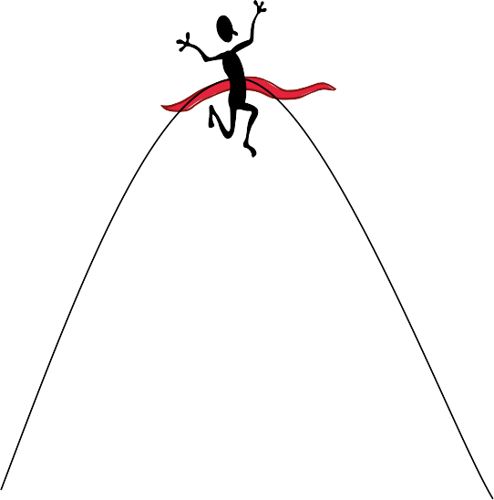

##### *Rate your stress levels*

Think of a recent performance in a sporting activity (or other performance if you do not have a sports example). Using a blue pen, mark an ‘X’ along the **bottom axis at the point indicating your level of arousal or stress at this time**.

High

Zone of peak performance

Performance

Low motivation, boredom

Disorganised, overwhelmed, anxious

Low

Low

Arousal/Stress

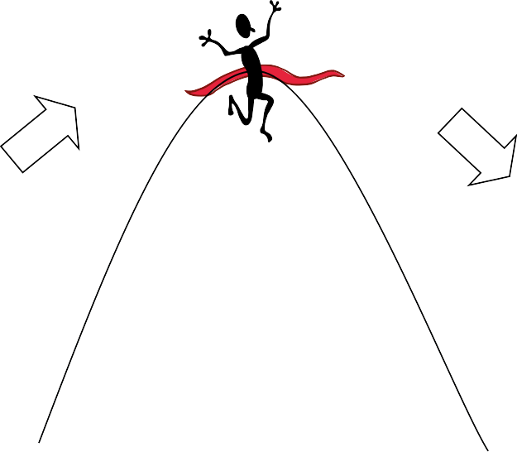

High

Strategies for getting (and staying) in ‘the zone’

|  |  |  |
| --- | --- | --- |
| **Aims** | **Objectives** | **Activities to achieve** |
| **1 Building up to the zone** | Increase arousal, motivation and drive | Focus on your dream.  Set goals (training and process goals). Write them down and place them where you can see them.  Surround yourself with positive people who will support your goals. |
| **2 Staying in the zone** | Maintain a balance | Review your goals regularly. Adjust as necessary.  Maintain a positive attitude and reward yourself for goals achieved.  Ensure that stress does not get out of hand by maintaining regular physical and mental relaxation. Use problem solving or get help if needed. |
| **3 Getting back to the zone** | Reduce stress/pressure—it is too high | Focus on relaxation techniques as a priority (see the following section).  Use positive and realistic thinking.  Get perspective on where you are at and ask for assistance if required to help you get back to where you need to be. You may wish to seek help from your coach, mentor, or psychologist for assistance with priorities, time management, goal-setting, thinking skills etc. |

## **Relaxation strategies**

1. Getting the mindset right: calm, positive and focused on the game plan.

Negative thinking or worry can increase stress and anxiety. Distractions can make a person lose focus and feel stressed about being out of control. Positive thinking can help people maintain perspective and stay calm.

Here are some examples of situations where calm, positive thinking will help these individuals:

* + There are seconds to go, the score is even. Matt has the ball and is lining up for a shot at the goals.
  + Phil is trying out for the rowing team and really wants to be selected.
  + Jessica’s competitor looks very strong and confident.
  + Brent has been criticised and feels he needs to ‘prove himself.’

1. Talking to someone about any worries or concerns. It might be a friend, family member, teacher, coach or sport psychologist. Often just talking can help sort out issues, ease tensions and allow a person to focus.
2. Regular relaxation with music or meditation can really assist the mind and body to relax.
3. Regular exercise is a great way to reduce stress. If a person is already training hard for sports, they might use stretching, yoga, Pilates, walking, tai chi or other forms of physical exercise to release stress.
4. Taking a warm, relaxing bath or shower.
5. Being with people who are supportive and caring.
6. Sleeping. (Did you know that teens need at least nine hours a night?)
7. Listening to music, drawing, writing, dancing, cooking or doing something else that is enjoyable.
8. Deep breathing—this is simple and very effective! Deep breathing will slow the heart rate, helping a person to immediately relax. This is a great technique people use to calm down before any competition, race or performance (or even to relax before sleep).

#### *Relaxation toolkit*

1 Think about strategies you use to get you into a positive mind set. List five strategies, which may include the ones listed above, that enable you to relax and explain why you believe they work for you.

### Breathing practice

iStockphoto.com/Boris Yankov

Practise taking three long, slow and controlled deep breaths. Find a comfortable position—standing, lying or sitting straight. Take the air in slowly through your nostrils expanding your lower belly and diaphragm and hold for three seconds. The inhalation should be easy and relaxed. Next, let it out in a slow controlled way through your mouth (the exhalation should be very slow and take approximately

eight seconds). Feel your abdomen deflate as the air escapes slowly—even making a ‘shhhh’ noise as it is released. Repeat this exercise several times. Notice how you are feeling.

#### *Reviewing relaxation*

1. You have been appointed coach of the up and coming tennis star, Ben Boomer. You notice he is disorganised and agitated. Brainstorm some strategies to ensure he will be in the peak performance zone for the finals:

Send him to a Phsychiatrist

1. Explain the relationship between stress and performance.

A bell curve

1. Describe some of the physical, mental and psychological reactions to stress.

Forgetfullness, Lack of Focus, anger and headaches

1. Describe one activity that helps you relax.

Listening to Music

# **Mental strategies for peak performance**

Jack Nicklaus (the golfer) once said that the game of golf is ‘90% mental’. This type of comment has been made about competing at the top level in many other sports. What it means is that when the sporting competition is at an elite level, all of the competitors have a high level of skill and fitness, and it is mental strategies to enhance performance that can give competitors the edge. Such strategies can be the difference between performing to the very best of a person’s ability and having an ‘off day’. It is crucial to know how to use the mind as a tool for success.

## **Routine**

Developing and sticking to a routine (or a preparation process) before a sports performance is a technique that allows the athlete to feel calm and in control and to mentally prepare before the competition. The routine allows the person to not have to think too much about what they should be doing in the lead up— they can focus on the performance. Some things that might form part of a routine might be the process of getting ready, the time they arrive at the venue, the way they organise equipment, their relaxation or mental preparation and the music they listen to. Some people even incorporate articles of clothing or special actions in their routines that help them to feel better or more confident before the performance (for example, wearing the ‘lucky’ underwear or Granny’s special medal, meditation, repeating personal affirmations, or speaking to a loved one.).

#### *Preparing a routine*

1. Design a pre-competition routine for a sporting performance.

Eat good food and train

1. Music is often used by athletes to both motivate their performance and reduce stress.
   1. Make a list of songs that you could use to motivate you and prepare you for a performance.

No title

* 1. List the songs that you find help you to unwind and relax.

No Title

* 1. Choose one of these songs to present to the class and explain what effect you believe it would have on an athlete’s performance.

## **Mental rehearsal**

Mental rehearsal is the process of using your imagination to create in your mind the sports performance that you desire. It is a process very like visualisation (seeing the images in your mind), but mental rehearsal incorporates other senses also, such as sounds, smells, feelings, touch and even taste to enhance the reality and intensity of the experience. It is like re-creating the entire experience in ‘real time’ (not faster or slower than reality) in your mind.

Mental rehearsal is a highly powerful tool. When used correctly, it can assist to greatly increase confidence as well as actual skill and performance level. How does it work?

1. When mental rehearsal is used to create a successful sports (or other) performance, the brain records this as a positive experience of success. This mental process allows a person to feel more confident and relaxed because they have ‘done it all before’ successfully (in their mind).
2. The mental rehearsal helps a person actually develop their skills much in the same way as physical practice does. The brain is going through the whole game process—thinking about the physical skills, tactics and timing. The brain is analysing and rehearsing the strategies required for the ultimate sports performance. Time spent in mental rehearsal is time well spent.

### A simple guide to mental rehearsal

1. Allow time to find a comfortable position where you can relax and not be disturbed. Breathe deeply and allow your body and mind to relax.
2. Create the sports performance you would like to achieve. Include sights, sounds, smells, feelings (for example, the touch of the furry ball, the feel of the wind, the look of your opponent, the sound of the crowd, the power of your serve, the elation at your victory). Immerse yourself in the experience.
3. Create your mental rehearsal in ‘real time’. Allow it to unfold minute by minute. Do not try to speed it up or play in slow motion.
4. Always make your imagery positive. See yourself doing well. If there are challenges or setbacks, see yourself overcome them to be successful. You do not want to rehearse failure or disaster!

###### Tips for mental rehearsal:

You can incorporate mental rehearsal into a pre-competition routine.

You can also use mental rehearsal to help you in other performances (such as taking exams, playing music or public speaking).

#### *Scripting a mental rehearsal*

Write a script for a mental rehearsal that you can use for a sports competition or performance. Remember to incorporate many elements (sights, sounds, touch, emotions, taste, etc.) to make it realistic. You can record this script and listen to it as you relax.

1 When thinking about an upcoming sporting performance or competition, why is it unhelpful to imagine or mentally rehearse negative experiences, failures or possible disasters?

Becuase it is negative

## **Improve focus and minimise distractions**

Maintaining focus is crucial in sports. One moment of distraction can cost you a point or even the match. A person who is not focused is likely to produce a performance that is not their best. Many things can cause a person to be distracted before or during a competition.

#### *Losing focus*

1 List all the distractions you can think of.

Life resposiblities, thoughts

The ability to focus can be increased through practice. Motivation and emotion is also linked to focus. Consider how the following situations might impact on focus.

* If a person did not care about accuracy and no-one was going to check, how accurate would the skills or performance be?
* If the person had just had a fight with their girlfriend, would this affect their performance?
* How accurate would they be if friends keep coming past and talking or their phone kept beeping with messages?
* If they were offered a million dollars to be very accurate and focused, do you think they could do it? How could they keep their focus?

### Stay focused and beat distracters—a look at the experts

* Australian tennis player Lleyton Hewitt regularly yells ‘Come on!’ to himself on court during play—this is a form of motivational self-talk to keep him alert and focused.
* Champion golfer Tiger Woods learnt how to keep his intense concentration on the course from a very early age with the assistance of his coach and father, Earl Woods. Earl would introduce random distractions while Tiger practised to help him learn to keep his focus.
* Ex-Australian cricketer Shane Warne endured many scandals, press and gossip about his off-field behaviour during his sporting career. He faced discipline for involvement in supplying information to a bookmaker, multiple accusations of infidelity and harassment, taking a banned substance and a marriage breakdown. Through it all, he still managed to regularly deliver exceptional performances on the field.

#### *Minimising distractions*

1. How did Shane Warne stay on top of the game? Discuss as a class.
2. Suggest a way that an athlete could minimise the distraction of heckling spectators.

Learn how to ignore sound

### Overcoming obstacles and disappointment

In sports, like in life, there are the highs and the lows. It is inevitable that there will be disappointments and various stumbling blocks in any sporting career.

#### *Dealing with challenges and disappointment*

* 1. Brainstorm some possible obstacles or disappointments a sportsperson may face. Consider the sportsperson’s physical and mental fitness, the team, the environment, the supports, the distractions and the competition.
  2. Sally Robbins was an outstanding Australian rower competing in the 2004 Olympics in the Women’s Eight. During the final, Sally was mentally and physically unable to go on and literally froze, dropping her oar and lying down in the boat while her team screamed at her to perform. She did not continue and the team came last. In the hours, days and weeks following, Sally was dubbed ‘lay down Sally’ and faced enormous speculation as to what happened as well as high emotion and criticism from team- mates, the media and the public.

Can you imagine how Sally might have felt?

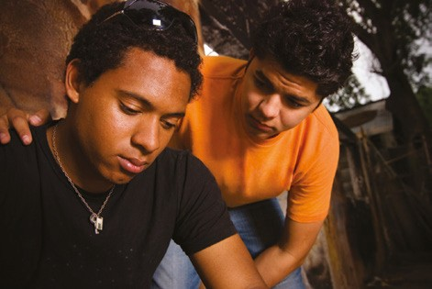Sometimes obstacles seem too big and too hard to overcome. However, in sports and in any field, persistence and determination will help a person move forward. Self-belief can help them achieve great things.

iStockphoto.com/Aldo Murillo

Strategies to assist in coping with any challenge include:

* Time (allow some time to overcome shock, disappointment, loss, hurt).
* Releasing the emotion (talking, therapy, writing in a journal, relaxation).
* Getting some perspective (recognising good things in life, other opportunities, having hope for the future).
* Reflecting and reframing (learning from the past, having a positive attitude about the future, setting new goals and moving forward).

## **Flow for the ultimate performance**

Psychologist Mihály Csíkszentmihályi has used the term ‘flow’ to describe the feeling and mental state that is experienced when a person is really immersed in an activity in which they are skilled and that they enjoy. The sensation is often experienced in sports, but also in other activities too. Flow occurs when a person is in their peak performance zone. They are prepared, motivated, ready and focused. The mind and body work in harmony to produce an excellent performance without thinking, worrying or planning—it seems effortless. Time seems to fly and the person feels energised, exhilarated and satisfied with a sense of accomplishment.

When a person is in a state of flow they are able to produce their best performances. It is not realistic to expect to achieve flow for every single performance. However, it is realistic for a person to work towards enabling themselves to experience flow as often as possible.

Provided are some scenarios that describe experiences of flow in sporting performances.

* With moments to go and only two points difference, Tom leaps for the football, rises above the pack and takes a spectacular mark. He barely pauses as he lines up for the goal. He does not seem to notice the anticipation and excitement in the crowd as he kicks confidently through the goalposts and the game is won.
* Jen’s eyes are focused as she sprints down the track toward the long jump pit. Her speed increases until she is going as fast as she possibly can. The spectators are a blur. She takes off at just the right point and she thrusts herself forward. High and fast, she is practically flying over the pit and knows even before she lands that this is her best jump ever. She feels sensational.

#### *Better performance*

1. Describe a situation (either sporting or in another setting) when you have experienced flow.
2. Why might athletes use a routine prior to a performance?
3. List some things a sportsperson can do to be in their peak performance zone so they are able to experience flow more often in sports performances.
4. Research a person who has faced a challenge or obstacle in sport. Did they overcome it? If so, how?

### Resource

iStockphoto.com/isitsharp

You may find the following resource helpful if you want more information on sport psychology:

Brandon, C. & Ivens. C. *Thinking Skills for Peak Performance*, Macmillan Education Australia, Melbourne, 2009